What is JavaScript

* HTML and CSS are markup languages; JavaScript is a programming language used to communicate with machines
* Keyboard Shortcuts: <https://developers.google.com/web/tools/chrome-devtools/shortcuts>
* Add image to a page

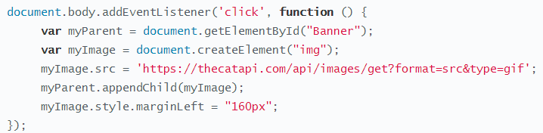

Data Types & Variables

* JavaScript Comparisons

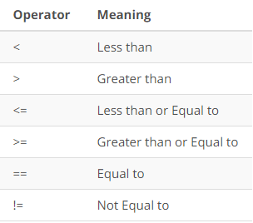

* Single line comments -> //
* Multiline comments -> /* */
* Reverses characters in a word

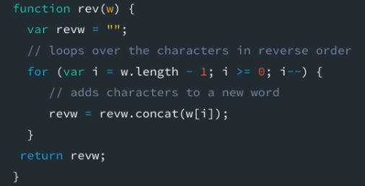

* Special Characters

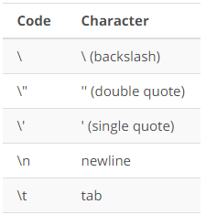



Conditionals

* Simple if statement

**var** weather = "sunny";

**if** (weather === "snow") {

console.log("Bring a coat.");

} **else** **if** (weather === "rain") {

console.log("Bring a rain jacket.");

} **else** {

console.log("Wear what you have on.");

}

* Logical operators

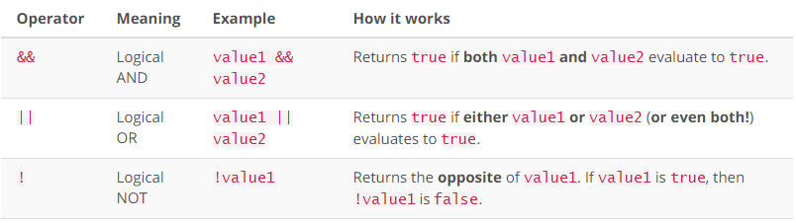

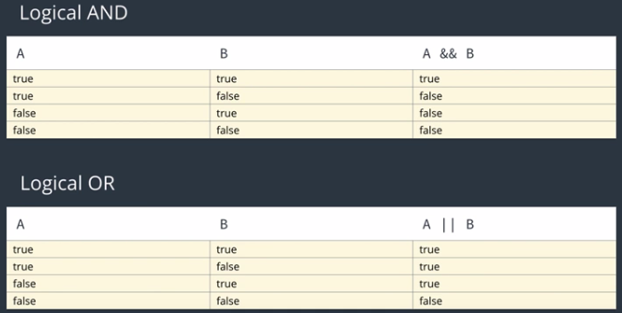

* Inherent falsy values: Boolean false, null, undefined, 0, “”, NaN
* Inherent truthy values: 42, “pizza”, “0”, “null”, “undefined”, {}, []
* Ternary operator: conditional ? (if condition is true) : (if condition is false)

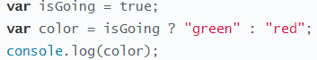

* Ternary Statements

**var** adult = true;

**var** preorder = true;

console.log("It costs $" + (adult ? "40.00" : "20.00") + " to attend the concert. Pick up your tickets at the " + (preorder ? "will call" : "the gate") + ".");

* Switch/break statements

**var** option = 3;

**switch** (option) {

**case** 1:

console.log("You selected option 1.");

**break**;

**case** 2:

console.log("You selected option 2.");

**break**;

**case** 3:

console.log("You selected option 3.");

**break**;

**case** 4:

console.log("You selected option 4.");

**break**;

**case** 5:

console.log("You selected option 5.");

**break**;

**case** 6:

console.log("You selected option 6.");

**break**; *// technically, not needed*

}

**default**:

output += "one copy of the Exploding Kittens card game.";

Loops

* While Loops

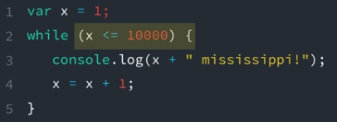

* For loops

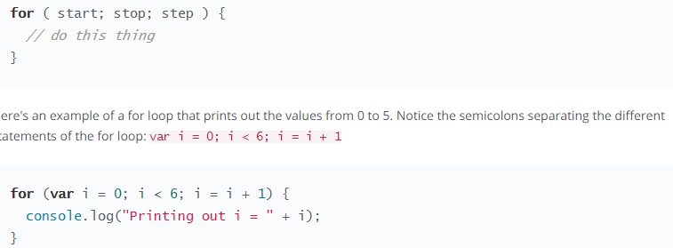

* Increments operators

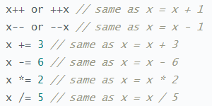

Functions

* If you have multiple variables then you would separate them with a comma

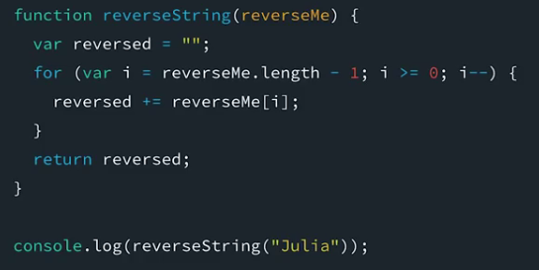

* Function expression

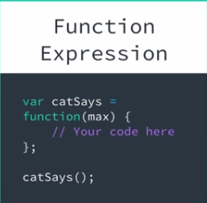

Arrays

* Define an array as such: var donuts = ["glazed", "powdered", "jelly"];
* Multi Data: var mixedData = ["abcd", 1, true, undefined, null, "all the things"];
* Nested Arrays: var arraysInArrays = [[1, 2, 3], ["Julia", "James"], [true, false, true, false]];

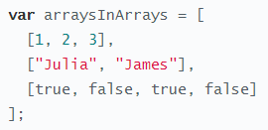

* Call an array by using the array variable and then the index: array[3];
* To replace a value in the array assign the value of the index: array[3] = “New value”
* Array properties and methods: <https://developer.mozilla.org/en-US/docs/Web/JavaScript/Reference/Global_Objects/Array>

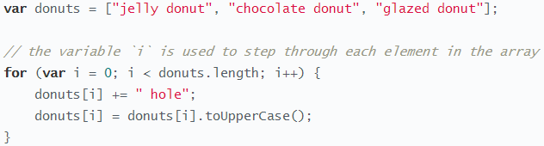

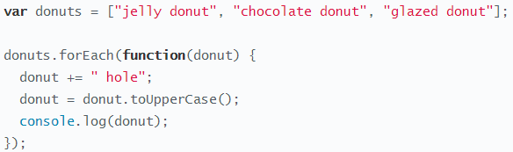

* forEach will not change the value, but only filter through it. To change values, you need to use the mapping method and write to a new array

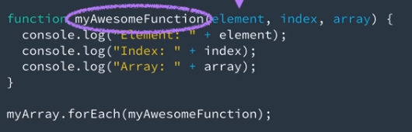

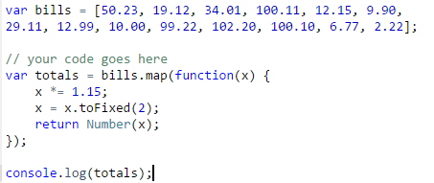

**for** (**var** row = 0; row < donutBox.length; row++) {

*// here, donutBox[row].length refers to the length of the donut array currently being looped over*

**for** (**var** column = 0; column < donutBox[row].length; column++) {

console.log(donutBox[row][column]);

}

}

Objects

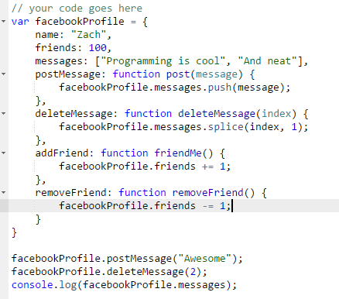

Intro to computer Science: <https://www.udacity.com/course/intro-to-computer-science--cs101>

Python: <https://www.udacity.com/course/programming-foundations-with-python--ud036>

JSON Class: https://www.copterlabs.com/json-what-it-is-how-it-works-how-to-use-it/

Compound Objects:

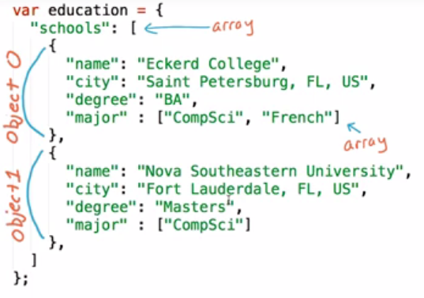

Validate JSON: <https://jsonlint.com/>

**work**

work contains an array of jobs. Each object in the jobs array should contain an employer, title, location, datesworked and description strings.

**projects**

projects contains an array of projects. Each object in the projects array should contain title, dates and description strings, and an images **array** with URL strings for project images.

**bio**

bio contains name, role, welcomeMessage, and biopic strings, contacts object and skills **array** of skill strings. The contacts object should contain a mobile number, email address, github username, twitter handle and location. The twitter property is optional.

**education**

education contains an array of schools. Each object in the schools array contains name, location, degree dates and url strings, and amajors **array** of major strings.   
  
education also contains an onlineCourses array. Each object in the onlineCourses array should contain a title, school, dates and url strings.

jQuery

* Always use the minified version, but you should use content delivery network because its considered faster

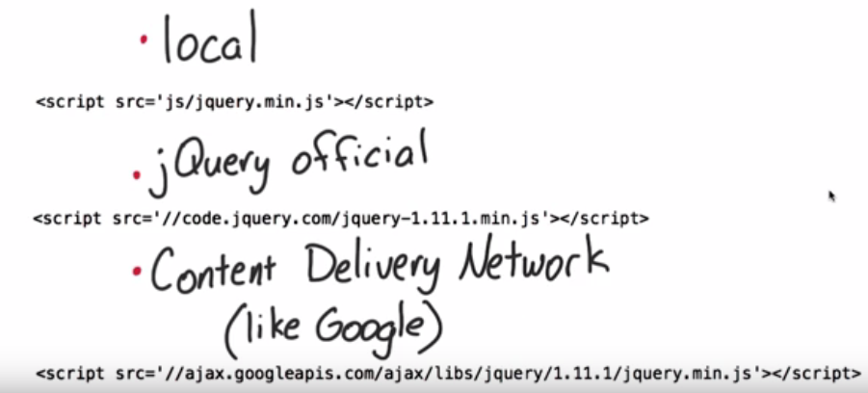

* You can call a selector by
  + Tag name $(‘div’)
  + Class name $(‘.class’)
  + ID $(‘#id’)

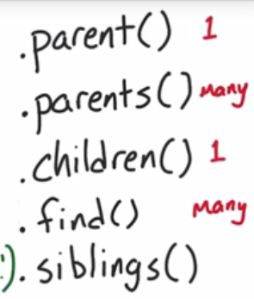

* jQuery API: <http://api.jquery.com/>

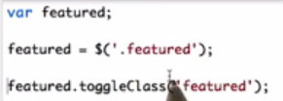

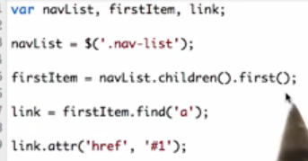

jQuery Event:

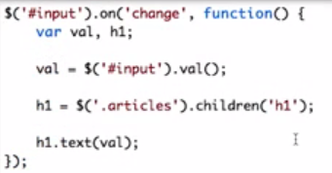

$("p").each(function() {

var text, num;

text = $(this).text();

num = text.length;

$(this).text(text + " " + num);

});

By wrapping your function inside a iQuery tag, it will not be executed until all the DOM elements are rendered.

$(**function**() {

$('img').attr('src', 'http://placepuppy.it/350/150');

})

jQuery Events

* You need three things to listen to events
  + The target element to listen to
  + The event we want to react to
  + The actions to take in response

ex. $(‘#myinput’).on(‘keypress’), function () {  
$(‘body’).css(‘background-color’, ‘#2727FF’);

* jQuery's Event Object: <https://api.jquery.com/category/events/event-object/>
* event.target property: <https://api.jquery.com/event.target/>
* DOM Level 3 Events: <http://www.w3.org/TR/DOM-Level-3-Events/>
* Convivence Method**:** [**http://api.jquery.com/category/events/**](http://api.jquery.com/category/events/)